Lab5: Graphic, Input handling and Sound: Button Smasher (Part 1)

Section 1 Date 13/11/2558

Student ID 5731015621 Name Jirapat Atiwattanachai

# Important Rules

* Any cheating (copying code, answer, picture, etc.) causes the lab’s score to be “**0**”.
* Any screenshots must be from YOUR own program.
* If the captured screenshot (e.g., JUnit Test Case) and the result of your program are different, the lab score will be “**0**”.
* Please put the following code in the top of ALL of your codes.

/**

* **@author** Your name (Your ID)

* **@version** 3 Apr 2015

* Lab5 part1 (2/2014) in 2110215 Prog Meth

*/

# Objective

* Finish Lab5 (part 1).
* Create runnable JAR file called “Lab5_part1_{ID}.jar”
* Zip your Eclipse project folder in the file called “Lab5_part1_project_{ID}.zip” (Make sure that source codes included)

# Part A: Problem Statement (12 points)

1. Try to run Lab5_ButtonSmasher.exe and capture the screenshot of the game.

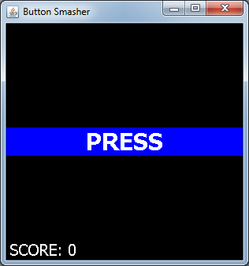

1. Describe how player obtains and loses score from this game. What are the keys to obtain and lose the score?

The keys to obtain and lose the score is spacebar.

If the player presses spacebar, he will get a score for 1 point when the screen shows “PRESS” and lose a score for 1 point when the screen shows “STOP”

1. If player presses and holds “space” button while the game’s screen shows “PRESS” or “STOP”, how many score that player will obtain from this game?

1 score for “PRESS”

-1 score for “STOP”

1. Is there player’s score increasing if player presses and holds “space” button.

No.

1. Can player’s score be negative? E.g. -1, -4, -7

Can’t.

1. Describe how “Polling” works.

Polling works by checking input asserting every ticks. When input change, it will sends value.

1. What is the difference between “Polling” and “Event-driven” input handling ?

Polling method checks input every tick but event-driven only do event when pressing input.

1. List all necessary “KeyListener” in this game (Note: not all KeyListener from Override) and describe how each KeyListener works.

KeyReleased detect spacebar releasing 🡪 set the spacePressed to false.

KeyPressed detect spacebar pressing 🡪 set triggered to true if spacePressed is false and set spacePressed to true.

1. Explain the font styles used in the game. What is the meaning of each font size that tells the player?

“PRESS” and “STOP” use Tahoma, bold, size 30. 🡪 Font("Tahoma",Font.BOLD,30);   
“SCORE: ” use Tahoma, plain, size 20. 🡪 Font("Tahoma",Font.PLAIN,20);

1. Capture the screenshot of the game after finishing your implementation. Note: the screenshot must be two images while the game shows “PRESS” or “STOP” on the game’s screen.

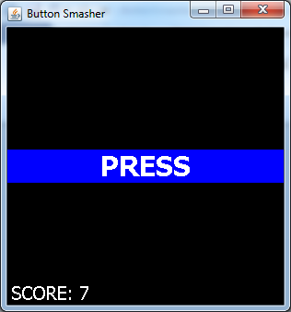

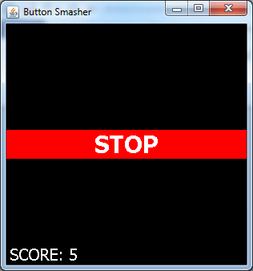

1. How player stop this game?

Close the game window

# Part B: Implementation (18 points)

1. Implement the ButtonSmasher game and check finished event using “🗸” in “Student Checker” column from the below table.

|  |  |  |  |  |  |
| --- | --- | --- | --- | --- | --- |
| **No** | **Classes** | **Criteria** | **Points** | **Sub Points** | **Student Checker** |
| 1 | Main | Set the title name to "Button Smasher" | 8 | 1 | 🗸 |
| 2 | “PRESS” and “STOP” must be in the center of the game’s screen and follow the game status. | 2 | 🗸 |
| 3 | Show score on the bottom left of the game’s screen. | 2 | 🗸 |
| 4 | Specify font type, font color, and background color correctly. | 2 | 🗸 |
| 5 | The game ends using Exit on close. | 1 | 🗸 |
| 6 | GameScreen | GameScreen has a size of 300 x 300 pixel | 10 | 2 | 🗸 |
| 7 | If player press “space” button, while show “PRESS”, increase score 1 point (+1) | 2 | 🗸 |
| 8 | If player press and hold “space” button while show “PRESS”, increase score 1 point (+1) | 2 | 🗸 |
| 9 | If player press “space” button while show “STOP”, decrease score 1 point (-1) | 2 | 🗸 |
| 10 | If player press and hold “space” button while show “STOP”, decrease score 1 point (-1) | 2 | 🗸 |
| **Total** | | | **18** | |  |